- Creating an Account: Go to the home page and click “Sign in”



- Entering The Access Area: Log in to the access area to submit your application and register.
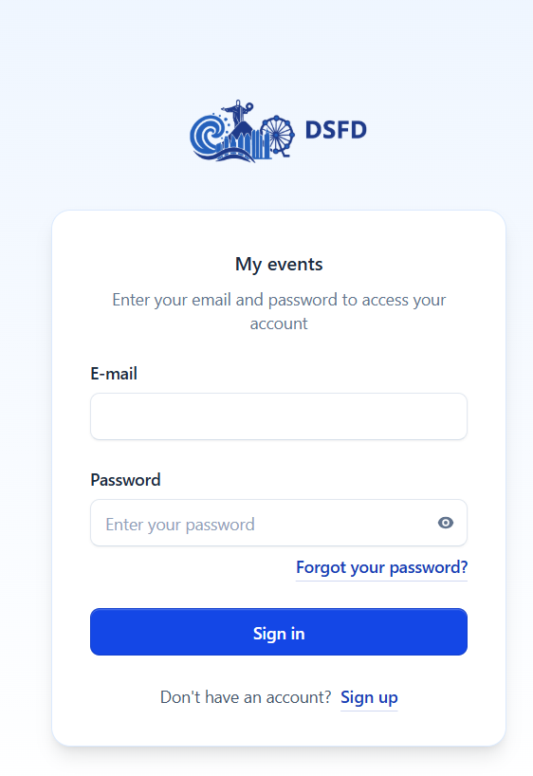

- Preparing for Submission: Go to the submission area
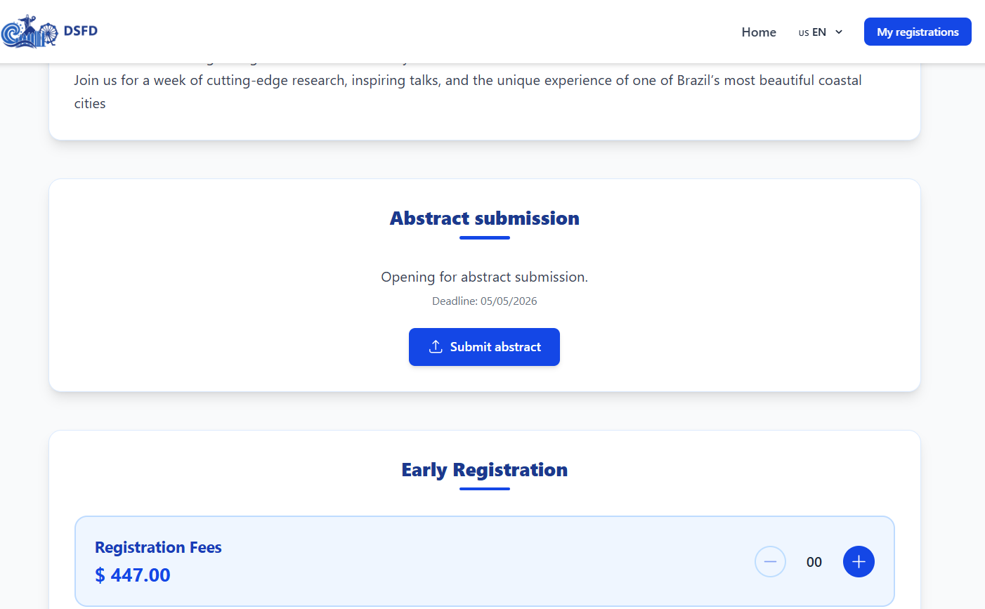

- Upload and Submission: In the submission area, fill in the required information and submit

